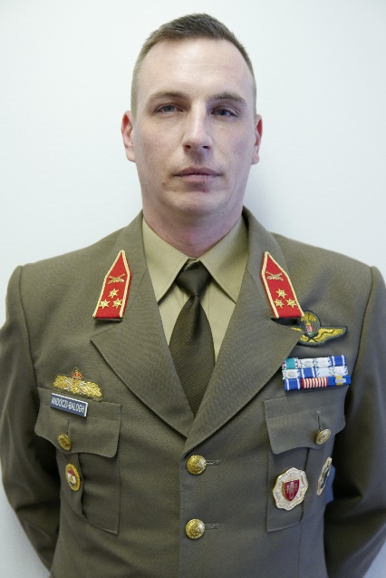
OF-2 (Cpt) ANDÓCZI – BALOGH, András Ádám
Address: 1101, Budapest, Hungária krt. 9-11.
Email: andoczi.balogh.andras.adam@uni-nke,hu
Phone: +36 1 432 9000 / 29140
Nationality: Hungarian
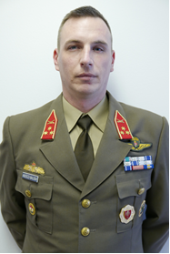
PROFESSIONAL EXPERIENCE
2005.09.01 | HDF 25th. Klapka György Light Infantry Brigade, (Tata)  1st. Light Infantry Battalion, 1st. Light Infantry Company, Heavy Weapons Platoon Platoon Leader;
2007.03.01. | HDF 25th. Klapka György Infantry Brigade, (Tata)  1st. Infantry Battalion; Battalion’s Mortar Platoon, Platoon Leader;
2008.11.01. | HDF 25th. Klapka György Infantry Brigade, (Tata)  1st. Infantry Battalion, 1st. Infantry Company, Heavy Weapons Platoon, Platoon Leader;
2009. 02.01. | HDF 25th. Klapka György Infantry Brigade, (Tata)  1st. Infantry Battalion, 1st. Infantry Company, Company Executive Officer
2010.06.01. | HDF 25th. Klapka György Infantry Brigade, (Tata)  1st. Infantry Battalion, Battalion Staff S3 officer;
2010.09.01. | Zrínyi Miklós National Defense University, Kossuth Lajos Faculty of Military Sciencie, Department of Operational Support, Instructor;
2011.02.01. | Zrínyi Miklós National Defense University, Kossuth Lajos Faculty of Military Sciencie, Department of Field Artillery, Instructor;
2012.01.01. | University of Public Service, Faculty of Military Science and Officer Training, Institute of Military Leader Training, Department of Operational Support, Field Artillery Instructor

EDUCATION
1997-2001 | Sylvester János Protestant High School (Budapest)
2001-2005 | Zrínyi Miklós National Defense University, Kossuth Lajos Faculty of Military Sciencie, Military Leader BsC, Field Artillery
2004 | Paratrooper training;
2006 | 1st Lieutanant evaluation course  Field Artillery Officer Basic Course, Fort Sill USA;  Scout Leaders Course, Fort Knox USA;
2010 | EXPAL M-08 60 mm Mortar Trainer Course;
2012 | CREVAL inspector course;
2012 | Captain evaluation course;
2017-2018 | University of Public Service, Faculty of Military Science and Officer Training Military Leader MsC;
2020 | GONIO Light/ JIM LR Trainer Course;

STUDIES AND DEGREES

OTHER ACADEMIC AND PROFESSIONAL ACTIVITIES
2004 | „Sword of St. Barbara” (Honour Graduated Field Artillery Cadet)
2006 | Field Artillery Badge, Honour Graduated;  Scout Badge;
2008 | „Althea” Europaen Security Defence Policy Service Medal;  Peacesupport service medal;
2009 | Commander of the HDF 25th. Klapka György Infantry Brigade – Financial Reward, For his outstanding work over a long period of time;  Commander of the HDF Joint Forces Command – Financial Reward, For his outstanding work over a long period of time;
2010 | Non Article 5 NATO Medal Afganistan;  Peacesupport service medal;  Ohio Commendation Medal
2011 | Service medal, Bronze;
2013 | Excellent instructor recognition – Fundation of Izsák Dezső „Fort The Good Artillerymen”;
2014 | Non Article 5 NATO Multiple Tour Indicator Afganistan;  Peacesupport service medal;
2015 | Non Article 5 NATO RS Medál, Békefenntartásért szolgálati jel;
2015 | Ofiicers Service Medal 3rd Degree for 10 years of service;
2018 | Excellent instructor recognition – Fundation of Izsák Dezső „Fort The Good Artillerymen”;
2019 | Subject Award from the Dean of the Faculty of Military Sciencies an Officer Training for his outstanding work over a long period of time;

LANGUAGE SKILLS
English | STANAG 2.2.2.2.;
French | ARMA, Basic level, military, komplex;

