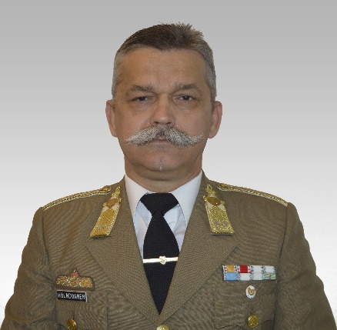
Hermann Holndonner
Address: 1101 Bp., Hungária krt. 9-11
Email: holndonner.hermann@uni-nke.hu
Phone: +36 1 432 9000/ 29-151
Place and Date of Birth: Sopron (Hungary), 1961.
Nationality: Hungarian

PROFESSIONAL EXPERIENCE
2012- | University of Public Service, Faculty of Military Siences and Officer Training, Department of Operations and Support, Instructor
2007-2012 | Zrínyi Miklós National Defence University, Kossuth Lajos Faculty of Military Siences, Department of Operations and Support Instructor
2006 | Ministry of Defence, Intel. Staff Officer
2001-2005 | Zrínyi Miklós National Defence University, Kossuth Lajos Faculty of Military Siences, Department of Intelligence, Instructor
1996-1998 | Kossuth Lajos Military College, Department of Intelligence, Teaching Assistant
1993-1996 | Zrínyi Milkós Military Academy, Student
1989-1992 | Kossuth Lajos Military College, Department of Intelligence, Teaching Assistant
1988–1989 | Kossuth Lajos Military College, Department of Intelligence, Company Commander
1986–1987 | 42. Military Intelligence Battalion (MIB), operation officer, Szombathely
1984–1986 | 42. Military Intelligence Battalion (MIB), company commander, Szombathely

EDUCATION
2007-2008 | Language Course English
2002-2006 | Zrínyi Miklós National Defence University Doctoral School of Military Siences
1994-1996 | Zrínyi Milkós Military Academy Operational Officer
1993–1994 | Zrínyi Milkós Military Academy Staff Officer Course
1991–1992 | Language Course German
1980–1884 | Kossuth Lajos Military College, First Lieutenant, Intellignce Officer, Teacher of Pdagogy in primary Education

STUDIES AND DEGREES

OTHER ACADEMIC AND PROFESSIONAL ACTIVITIES
2011 | Soldier of the Years (education)
2011 | Service Merit Award Decorated With Laurel Wreath
2010 | Service Medal for Flood Control
2007 | Service Medal for Homeland Defence Gold degree
2007 | Kossuth Lajos Military Sience Foundation (curator)
2004 | Excellent Instrukror of Zrínyi Miklós National Defence University
2004 | Service Medal for Homeland Defence Silver degree
2002 | Officer’s Service Award II.degree (20 years)
1994 | Officer’s Service Award III.degree (10 years)
1989 | Service Medal for Homeland Defence Bronze degree

LANGUAGE SKILLS
Russian | advanced level
German | advanced level
English | basic level

