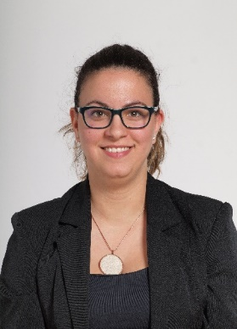
Petra Kovács
Address: Budapest, Hungária krt. 9-11.
Email: kovacspetra@uni-nke.hu
Phone: +36 1 432 9000 / 29415
Place and Date of Birth: Debrecen, 1991.07.14.
Nationality: hungarian

PROFESSIONAL EXPERIENCE
2015-2016 | Ministry of Defence, war grave care
2016-2018 | Institute and Museum of Military History, war grave care
2018-2019  2019- | General Electric/Genpact, A/P operation specialist  NUPS, Doctoral School of Military Engineering, student coordinator

EDUCATION
2010-2013 | University of Debrecen, Slavic Studies – Polish philology
2013-2015 | Eötvös Lorand University –Polish Language and Literature
2018– | NUPS Doctoral School of Military Science

STUDIES AND DEGREES

OTHER ACADEMIC AND PROFESSIONAL ACTIVITIES
2019- | NUPS Doctoral Student Council, delegate
2019- | DOSZ Department of Military Sciences, president

LANGUAGE SKILLS
English | C1
Polish | C1

