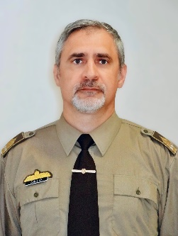
Lt. Col. Attila Kállai, PhD
Address: 9-11 Hungária Blvd., Budapest 1101
Email: kallai.attila@uni-nke.hu
Phone: +36 1 432 9000 / 29442
Nationality: Hungarian

PROFESSIONAL EXPERIENCE
1991–1993 | Designer-topographer Officer, Tóth Ágoston Mapping Institute, Hungarian Defense Forces (HDF)
1993–1996 | Instructor, Kossuth Lajos Advanced Military School, HDF
1996–1998 | Assistant Lecturer, Kossuth Lajos Faculty of Military Science (KLFMS), Zrínyi Miklós National Defense University (ZMNDU)
1998–2009 | Assistant professor, Department of Military Cartography and Geography, ZMNDU KLFMS
2007–2010 | Director, Department of Management Science ZMNDU
2009–2010 | Associate Professor, Department of Geoinformatics, ZMNDU KLFMS
2010–2011 | Head of Department, Department of Geoinformatics, ZMNDU KLFMS
2011–2012 | OIC Military Mapping and Geo-Info Analysis, UNIFIL JGIS; SNR of Hungarian Staff Officers, 6th Shift
Since 2012 | Associate Professor, Faculty of Military Science and Officer Training (FMSOT), National University Of Public Service (NUPS)

EDUCATION
1982–1986 | Asztalos János Vocational Secondary School of Horticulture and Surveying
1986–1991 | Leningrad Higher Military-Topographic Command School (LVVTKU)
1998–2001 | Doctoral School of Military Sciences, ZMNDU

STUDIES AND DEGREES
2008 | PhD, Military Sciences

OTHER ACADEMIC AND PROFESSIONAL ACTIVITIES
Since 1997 | Member, Hungarian Association of Military Science
Since 1999 | Member, Hungarian Society of Surveying, Mapping and Remote Sensing
2007–2010 | Secretary of Doctoral Council, ZMNDU; Secretary of Habilitation Committee, ZMNDU
2008–2010 | Member, University Quality Committee

LANGUAGE SKILLS
English | Intermediate
Russian | Advanced

