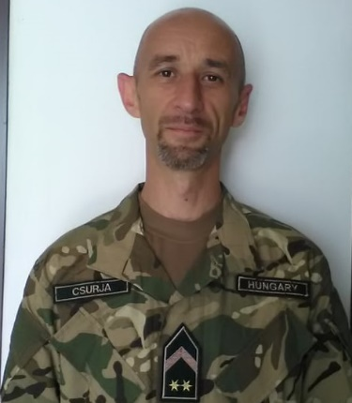
Gábor CSURJA
Address: Budapest, X. Hungária krt. 9-11., Building „A” 8th floor 807.
Email: csurja.gabor@uni-nke.hu
Phone: +36 1 432 9000 / 29356
Place and Date of Birth: Balassagyarmat, 1978. 06. 12.
Nationality: Hungary

PROFESSIONAL EXPERIENCE
2007–2018 | HDF 25. Klapka György Infantry Brigade, 1. Infantry Battalion, CIS section, signal WO
2004–2007 | HDF 25. Klapka György Light Infantry Brigade, 1. Light Infantry Battalion, HQ company, signal platoon, crypto station commander
2000–2004  1997-2000 | HDF 5. Kiskun EW Company, signal platoon, platoon NCO  HDF 5. Kiskun EW Regiment, signal company, Radiostation commander

EDUCATION
1996–1997 | HDF Military Signal Secondary School, NCO Academy
1992–1996 | HDF Military Signal Secondary School

STUDIES AND DEGREES
-

OTHER ACADEMIC AND PROFESSIONAL ACTIVITIES
-

LANGUAGE SKILLS
English | STANAG 1.1.1.1.
English | Intermediate „A”

