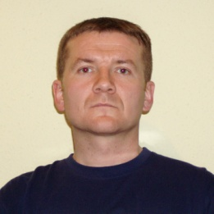
Kálmán DÉNES
Address: H-1101 Budapest Hungária krt. 9-11.
Email: denes.kalman@uni-nke.hu
Phone: +36 1 432 9000 / 29416
Place and Date of Birth: Szombathely, 24th May 1975
Nationality: Hungarian

PROFESSIONAL EXPERIENCE
1997–1998. | HDF SZKSZIK Szentendre, educational officer
1998–2000. | HDF SZKSZIK Szentendre, chief educational officer
2000–2001. | HDF SZKSZIK Szentendre, company commander
2001–2002. | HDF KTSZI Szentendre, company commander
2002–2006. | Zrínyi Miklós National Defence University, instructor
2006–2012. | Zrínyi Miklós National Defence University, assistant professor
2012–2014. | National University of Public Service, assistant professor
2014– | National University of Public Service, associate professor

EDUCATION
1989–1993. | Szombathely Mechanical Engineering Technical Secondary School
1993–1997. | Zrínyi Miklós National Defence University, Lajos Kossuth Military College Faculty, Engineer officer, Szentendre
1998–2001. | University of Technology and Economics of Budapest, MSc civil engineer
2005–2008. | Zrínyi Miklós National Defence University, Doctoral School of Military Engineering, PhD degree

STUDIES AND DEGREES
2005–2008. | Zrínyi Miklós National Defence University, Doctoral School of Military Engineering, PhD degree

OTHER ACADEMIC AND PROFESSIONAL ACTIVITIES
2019– | „Engineer Military Bulletin”, Editorial Board Member

LANGUAGE SKILLS
English | STANAG 2,2,2,2
German | Intermediate „C”

